**Artificial Intelligence**

**Natural Disasters Intensity Analysis & Classification Using AI**

|  |  |
| --- | --- |
| **Date** | **21-11-2022** |
| **Team ID** | **PNT2022TMID38465** |
| **Project name** | **Natural disasters intensity analysis and classification using AI** |

**Proposed Solution - Natural Disasters Intensity :-**

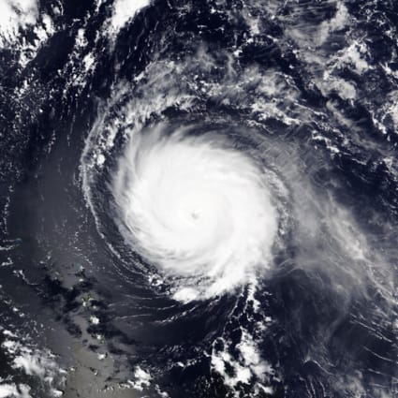

**Nature-based solutions to disasters:-**

**Climate change is increasing the frequency, intensity and magnitude of disasters, leading to a higher number of deaths, injuries and increased economic losses.**

**Nature-based solutions, such as conserving forests, wetlands and coral reefs, can help communities prepare for, cope with, and recover from disasters, including slow-onset events such as drought.**

**Nature can be a cost-effective and no-regret solution to reducing risks from disasters, complementing conventional engineering measures such as sea walls and storm channels.**

**However, investment in ‘natural infrastructure’ is underexplored in policies aimed at reducing risk**

**There is an urgent need to invest in nature-based solutions to disaster risk reduction in order to minimise our vulnerability to future events.**

**AI and its use in DRR:-**

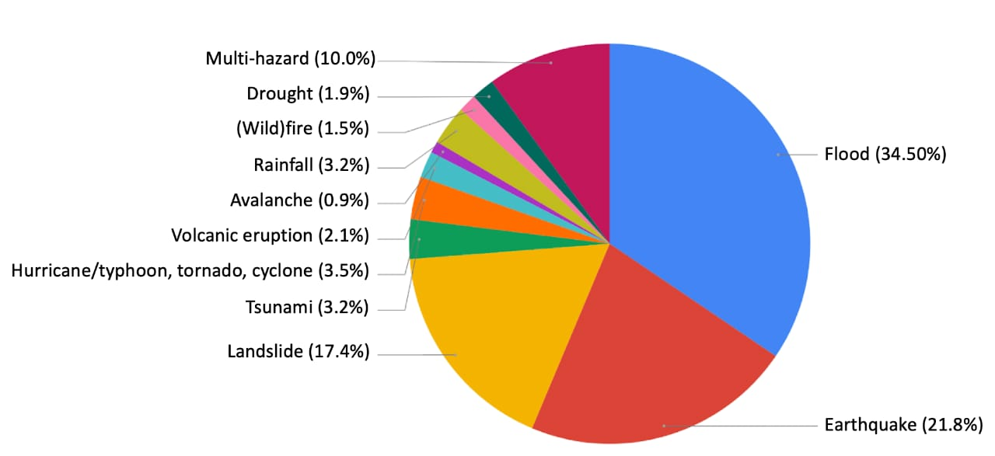

**Application of AI : To the detection and forecasting of natural hazards and disasters derived from a preliminary literature survey covering articles published between 2018 and 2021 with a focus on (future) DRR applications. These results show an overrepresentation of certain natural hazard types, particularly floods, earthquakes, and landslides.**

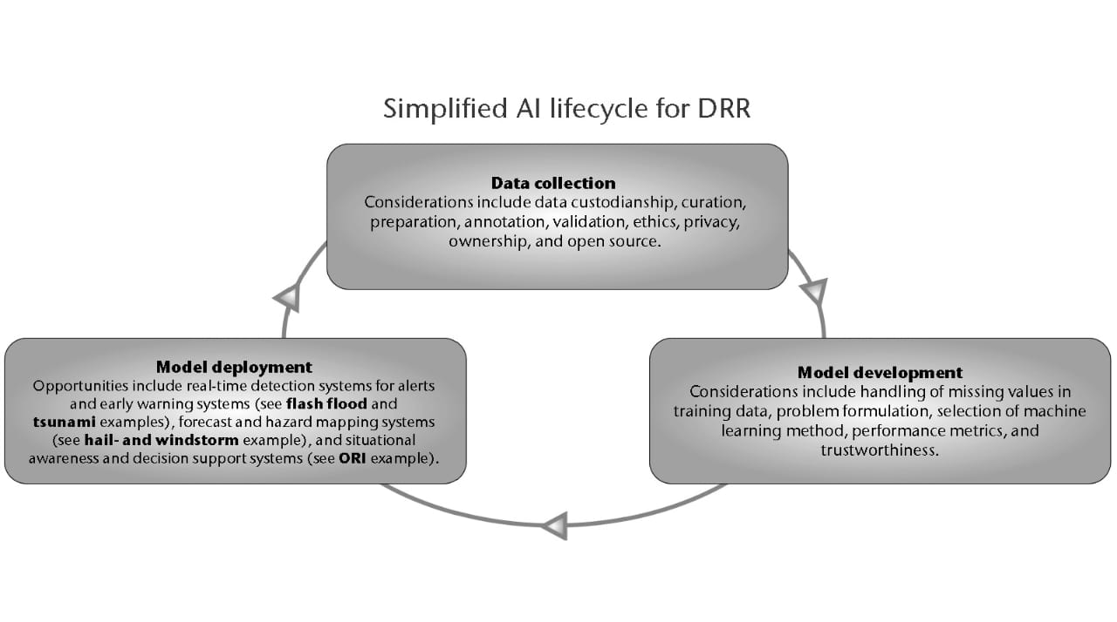

**Challenges to the use of AI for DRR:-**

**When applying AI for DRR, challenges can appear at any stage of the life cycle (Figure 3): at the data, model development or operational implementation stage.**

**During the collection and handling of data, it is important to consider: (a) biases in training/testing datasets, (b) new distributed AI technologies within the data domain and (c) ethical issues. In terms of biases in training/testing datasets, it is important to ensure that data are correctly sampled and that there is sufficient representation of each pattern for the problem in question. Consider, for instance, the challenge of building a representative dataset containing examples of extreme events (which are, by nature, rare). Also, imagine the possible costs of failing to provide appropriate data, for instance, wrong predictions or biased outcomes.**